Secured MCP Registry
SecureMCP provides a governed way for AI applications to find and use external capabilities. Publishers submit MCP services to the Secured MCP Registry, where identity, safety and permission information can be reviewed before those services are made available.
When an AI application needs a capability, its Agent Host and MCP Client use an approved configuration to connect to a Secured MCP Server. The server returns the available tool descriptions, the language model selects an appropriate tool, and the MCP Client carries the request and response between the application and the server.
SecureMCP applies safeguards throughout this journey. Policy and consent establish what is allowed; trust checks confirm the service and version; the Reflexive Core watches for changing behaviour; and provenance, audit and alerts keep important activity visible and accountable.
In simple terms: the registry decides what may be trusted, the MCP Client manages the connection, the Secured MCP Server performs the approved work, and SecureMCP continues to monitor the interaction.

How data flows through SecureMCP
The operating model can be understood as five business steps. The detailed MCP protocol sequence is intentionally kept outside this executive view.
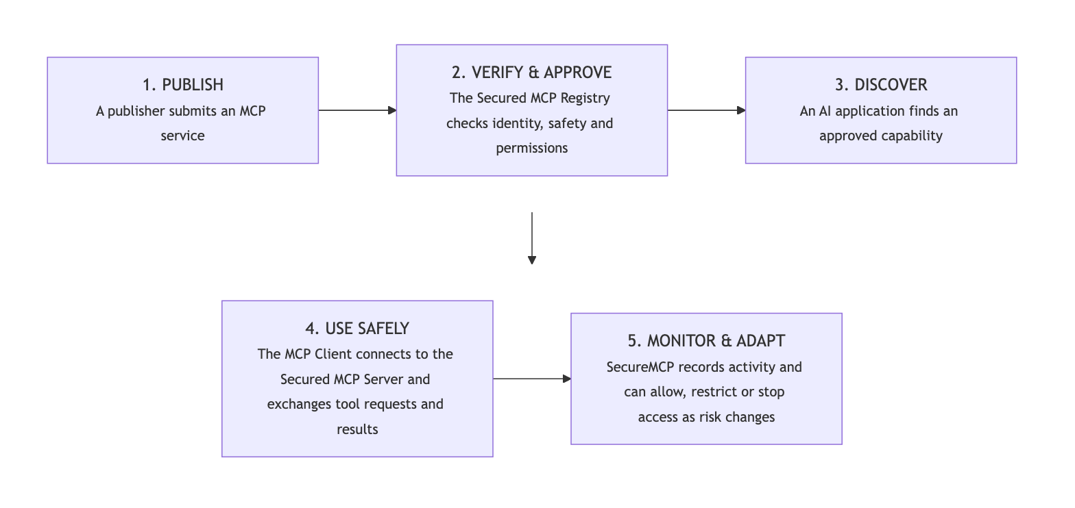
Five-step view: publish, verify, discover, use safely, and monitor

What each part does
1. AI Agent / LLM Application — understands the user’s request, sees the approved tools made available by the Host, and decides when a tool may help.
2. Agent Host — runs the user experience and language model, creates MCP Client connections, applies approvals, and provides tool descriptions and results to the model.
3. MCP Client — maintains one protocol connection to an MCP Server, requests the tool list, sends approved tool calls, and returns tool responses to the Host.
4. Secured MCP Registry — is the governed system of record for publishers, MCP services, approved versions, connection information and lifecycle status.
5. Trust & Verification — confirms the publisher, server version, certification, attestation and current suspension or revocation status.
6. Policy Enforcement — checks whether a user, agent or MCP Client may perform a particular action under the organization’s rules.
7. Reflexive Core — compares current activity with expected behaviour and can allow, restrict, require approval or stop an action as risk changes.
8. Secured MCP Server — publishes tool descriptions and performs approved tool operations through SecureMCP runtime controls.
9. Provenance & Audit — records important identities, decisions and outcomes so activity can be traced and reviewed.
10. Alerts & Notifications — informs the responsible user, publisher or administrator when attention or action is required.
Document scope: This is the business-level operating model. A separate technical appendix can show initialization, tools/list, tools/call, normal/elevated/critical branches, connection shutdown and transport-specific details.

Who takes part?
1. Publisher — The person or organization that creates and maintains an MCP service.
2. Secured MCP Registry — The trusted platform that verifies, approves, publishes and monitors MCP services.
3. AI Agent / LLM Application — The user-facing application that decides when an MCP capability is useful.
4. Agent Host / MCP Client — The software that connects the AI agent to an approved MCP service.

Publisher journey
The publisher journey is designed to turn responsible innovation into a repeatable path: helping teams bring valuable MCP services to market while making trust, transparency and lifecycle accountability part of the experience from the start.
1. Create — The publisher builds an MCP service and explains what it does.
2. Describe — The publisher provides ownership, capability, permission and version information.
3. Submit — The service is sent to the Secured MCP Registry for review.
4. Verify — The registry checks identity, safety information, permissions and the service’s signed proof.
5. Approve and publish — An approved service becomes discoverable to eligible AI agents and applications.
6. Maintain — The publisher releases updates and responds to any new safety findings.

AI Agent / LLM Application journey
For AI agents and LLM-powered applications, the Secured MCP Registry creates a safer path from intent to action. The agent can discover useful capabilities, understand their trust posture, and invoke them through governed access rather than relying on ad hoc integrations.
1. Understand the need — The AI agent identifies a capability required to complete the user’s task.
2. Discover — The MCP client searches the Secured MCP Registry for suitable approved services.
3. Check — The registry confirms the publisher, version, safety status and requested permissions.
4. Authorize — Access is allowed only when organizational policy and user permission requirements are met.
5. Use — The AI agent invokes the approved MCP service and receives the result.
6. Record — The important decisions and actions are recorded for accountability.
7. Respond to change — Access can continue, require approval, be restricted or be stopped when risk changes.

The Components of SecureMCP
SecureMCP brings together connected safeguards that make trusted AI extensibility practical at scale. Each pillar answers a different business question, from “Can we trust this service?” to “Should this action continue right now?”—and together they create the foundation for confident, governed AI growth.

1. Secured MCP Registry
The trusted system of record for MCP publishers, services, versions and security status.
It gives organizations a strategic control point for AI extensibility—one governed place to publish, discover, approve, suspend and retire MCP services as the ecosystem grows.

2. Tool Marketplace and Discovery
The approved catalogue through which AI agents and applications find suitable MCP capabilities.
It makes discovery useful without treating every available service as automatically trusted.

3. Certification and Attestation
The evidence that a publisher and service completed the required checks for a particular version.
Signed proof allows an organization to verify what was assessed and whether that proof is still valid.

4. Policy
The organization’s rules for who may do what, under which conditions and within which limits.
Policy decisions can allow an action, deny it or require additional approval.

5. Contracts
A clear usage agreement between the AI agent and the MCP service.
It defines purpose, permitted scope, obligations and limits before a capability is used.

6. Consent
The record of permission from the appropriate user, owner or organization.
Consent ensures that technically possible actions are not performed without appropriate authority.

7. Provenance
A traceable history of where a request came from, which decisions were made and what happened.
Provenance supports accountability, investigation and confidence in the final outcome.

8. Reflexive Core
The adaptive safety layer that observes behaviour, detects drift and responds to changing risk.
It can allow normal activity, request approval, restrict access or stop a critical action.

9. Introspection
The ability to examine the current request, actor, context and risk before or during execution.
Introspection gives the Reflexive Core the context required to make a meaningful assessment.

10. Alerts
The shared security event and notification capability.
Alerts bring unusual activity, policy failures and urgent risks to the attention of responsible people and systems.

11. Gateway and Audit
The governed entry point for security-aware MCP access and a unified view of security activity.
It simplifies oversight by bringing access and audit information into one controlled layer.

12. Compliance
The reporting layer that turns security evidence into information suitable for governance and assurance.
It helps demonstrate that required controls are operating and provides material for reviews or audits.

13. Federation
A way for trusted SecureMCP environments to share approved trust information.
Federation supports collaboration across teams or organizations without removing local control.

14. Certificate Revocation
The mechanism for declaring that previously trusted proof must no longer be accepted.
Revocation protects users when a credential, publisher or service version becomes unsafe or compromised.

15. Sandboxed Execution
An isolated environment for running higher-risk capabilities with controlled access to systems and data.
Sandboxing limits the impact of unexpected or unsafe behaviour.

Platform foundations around the pillars
The PureCipher Secured MCP Registry adds the practical product services needed to turn these pillars into an operating model for trusted AI ecosystems:
Identity and role-based access: confirms publishers, administrators, reviewers and registered MCP clients.
Publisher and submission services: support packaging, preflight checks, submission and version updates.
Moderation and lifecycle management: support approval, rejection, suspension, deprecation and deregistration.
Client identity and tokens: give each AI agent, service or framework a controlled identity.
OpenAPI ingestion and MCP gateway: allow eligible API operations to be presented through governed MCP toolsets.
Notifications: inform publishers, reviewers, administrators and client owners when action is required.
Durable records: retain registry, account, security, client and audit information.

How the pillars work together
Establish trust: Identity, the Secured MCP Registry, certification and revocation establish whether a service should be considered trustworthy.
Set boundaries: Policy, contracts and consent establish what the AI agent is allowed to do.
Execute safely: The gateway, sandbox and MCP server apply those boundaries during use.
Observe and adapt: Introspection and the Reflexive Core detect changing behaviour and adjust the response.
Maintain accountability: Provenance, audit, alerts and compliance preserve evidence and bring important events to attention.
Share trust carefully: Federation allows trusted environments to collaborate while retaining local governance.

The message to take forward
Trust enables innovation — Publishers should be able to bring new MCP capabilities forward quickly, with clear evidence that they are safe, accountable and ready to use.
Discovery should be governed by confidence — AI agents should find approved capabilities through trusted pathways, not fragmented or opaque integrations.
Trust must be continuous — Assurance should follow every MCP service across its lifecycle, from publication to update, suspension or retirement.
Governance should adapt in real time — The Reflexive Core should help the system respond as behaviour, context and risk evolve.
Scale should remain accountable — As adoption grows, every important decision should remain traceable, reviewable and useful for strengthening trust.

